

A Project Report On

**Hospital Management System**

**By**

**Soundarya Kamurti**

**Shruti Margar**

**Prem Waghela**

**Batch:** 2021– 6120

**Center: Salem**

Under the Guidance of,

**Mamta Boga**

**Technical Trainer**

**EduBridge**

(School of coding)

**Introduction:**

Our project explains about the Hospital management system.This project mainly explains that patient can take appointment online and book test appointment without wasting our time we can take it from online.

Our Project Include

**Modules:-**

* Admin Module
* Doctor Module
* Pathology Module
* Patient Module

I have developed this Application in **Java, SpringBoot, Hibernate (JPA) and MySQL.** It’s a web-based projects so I have used **HTML, CSS, JavaScript and Bootstrap**.

The main feature of the project is to take appointment easier. You can access this website from anywhere and everywhere.

In Doctor module, admin can add the Doctor’s name and their degree where users can categories their appointment. Admin can only see the admin page which appointment is book for which doctor.

In Pathology module, user can easily see which test available in the hospital.On the basis of that information user can book their appointment.

In Patient Module, user should be book their appointment for what their reuirement.After booked their appointment they can came at their time.

**Software Requirements:**

**Front end:** Java/J2EE technologies HTML, CSS, JavaScript, Bootstrap, Hibernate(JPA).

**Back end**: MySQL workbench 8.0.23CE.

**Middleware/Server:** Apache Tomcat v8.5. IDE: Eclipse IDE for Java EE Developers

**Browser:** Best result on Google Chrome

**Operating System:** Window 10.

# Create a database of hospital management sys:-

# Screenshots:-

**Admin Page:**

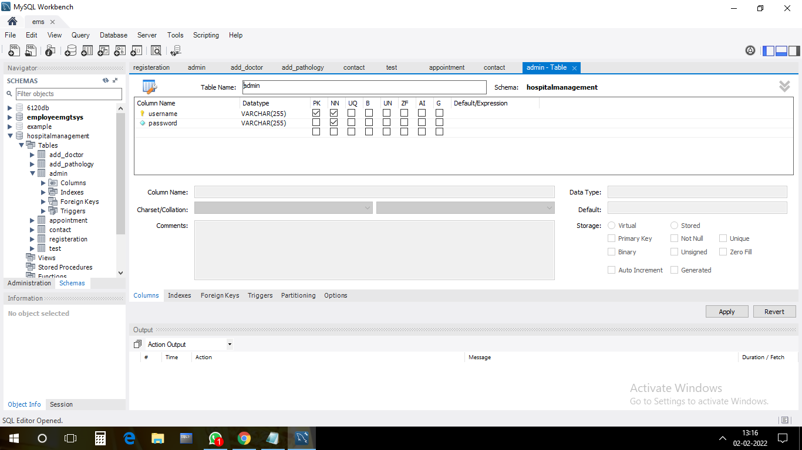

**Doctor Page:**

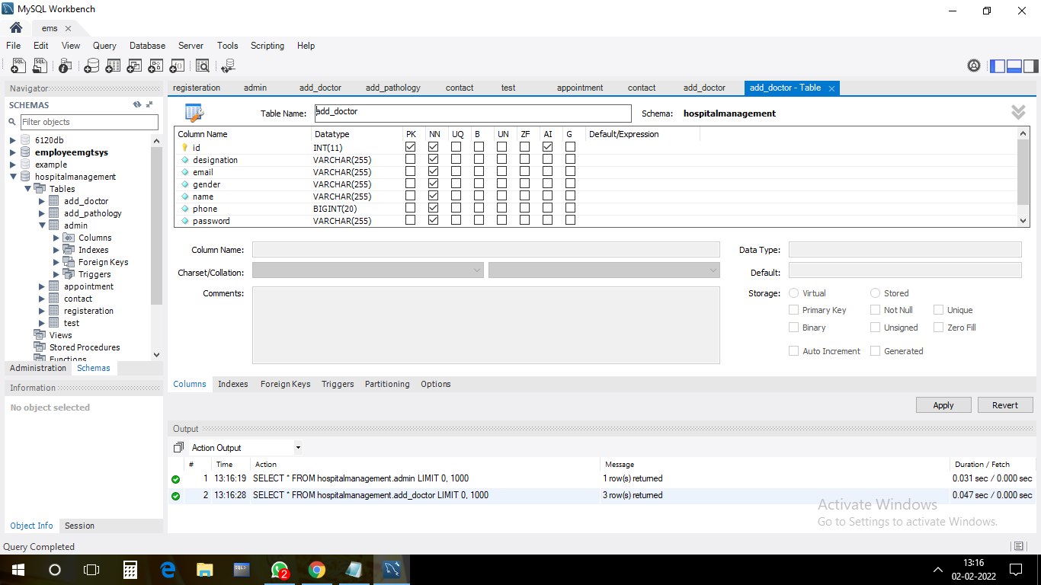

**Pathology Page:**

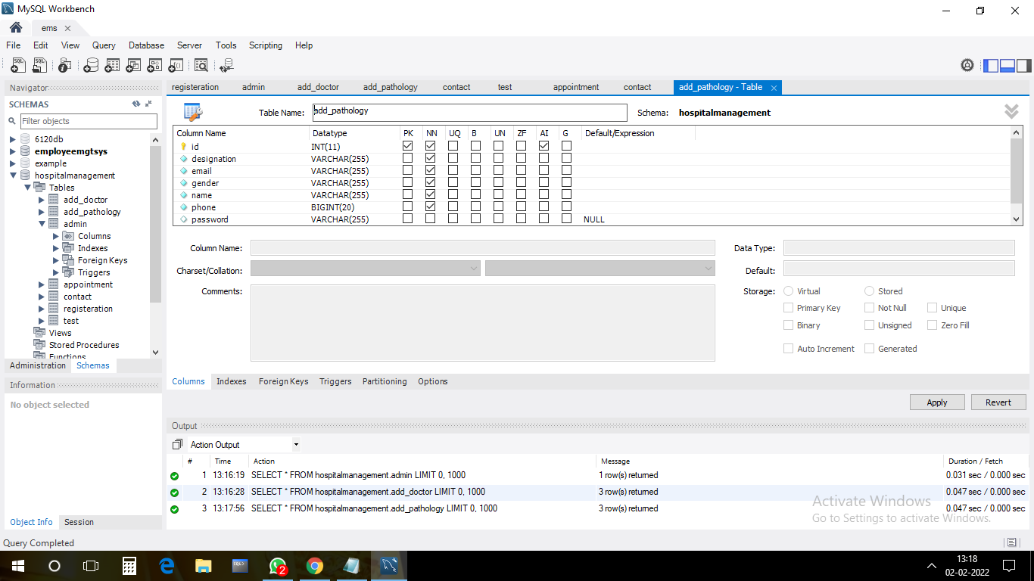

**Patient Page:**

**1.Patient Appointment**

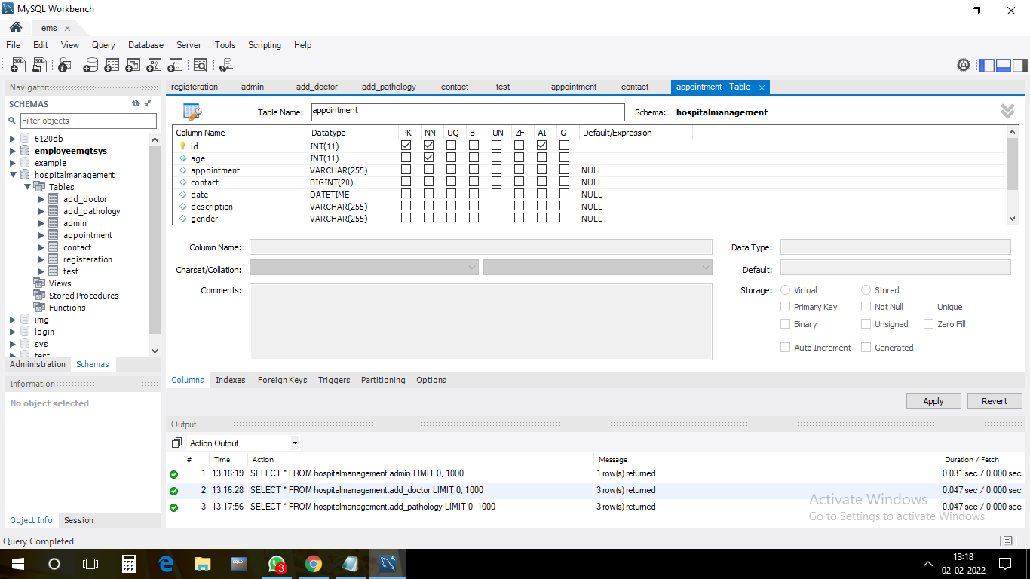

**2. Page Test:**

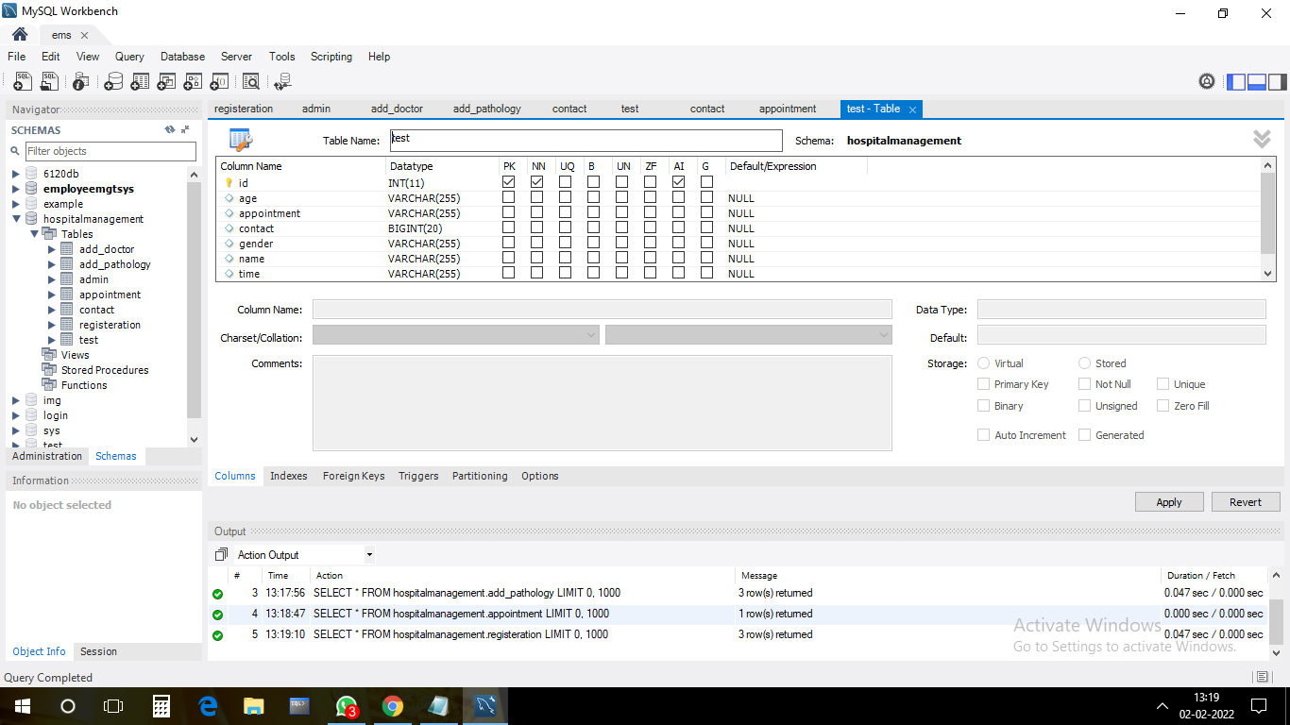

**HTML PAGES**

**1.Home Page**

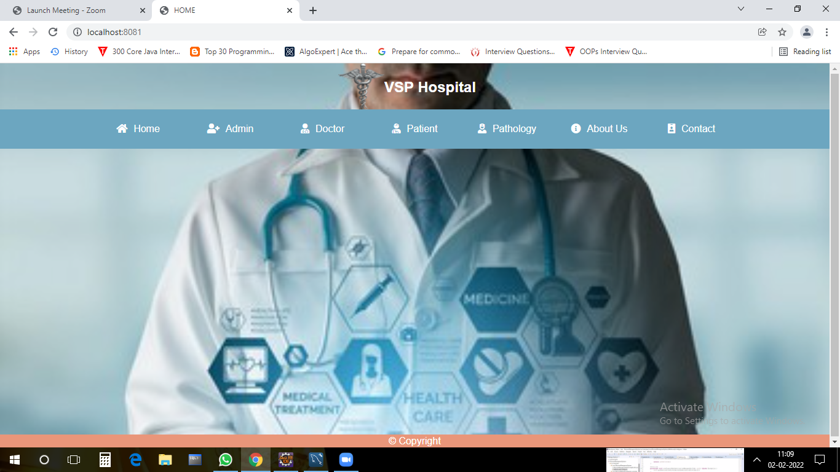

**2.Admin Page**

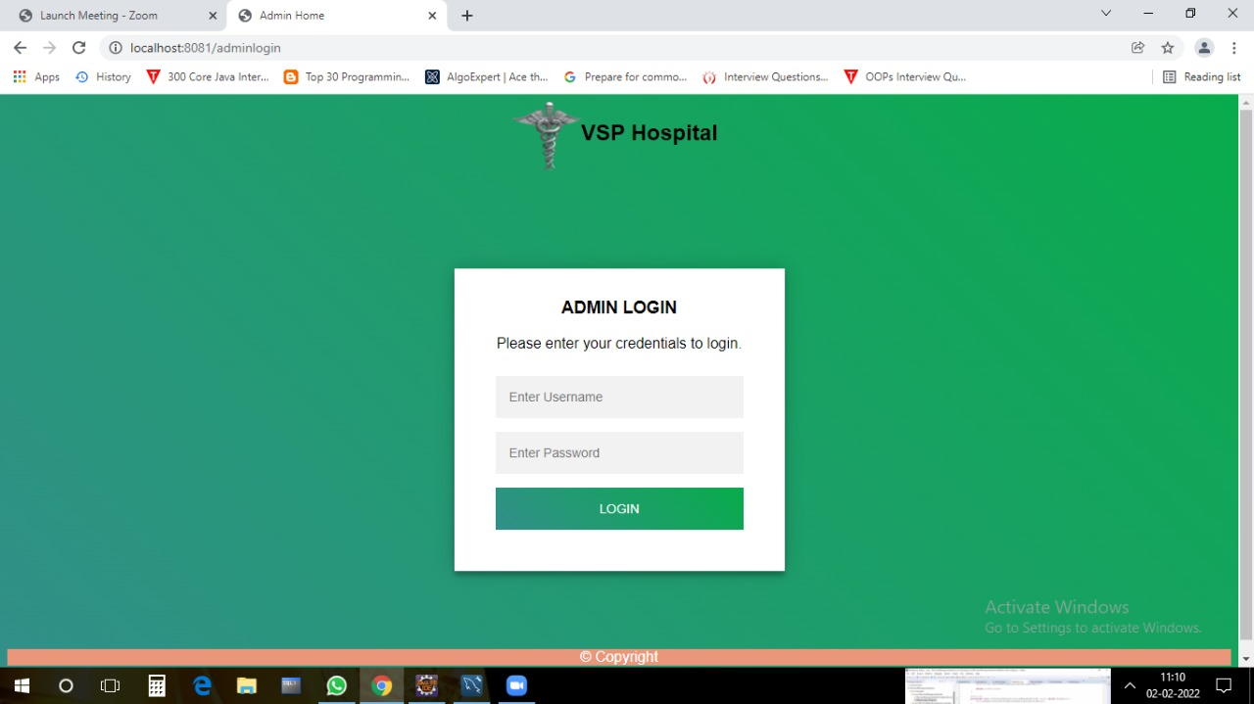

**2.1 Admin Home**

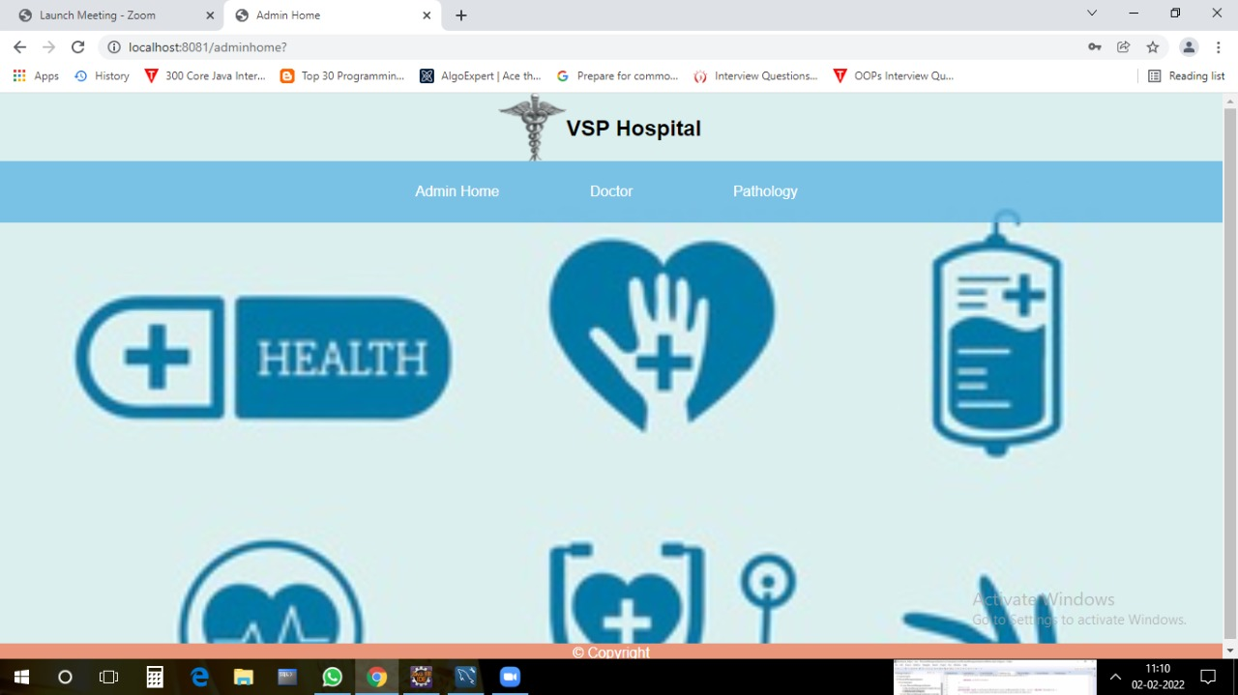

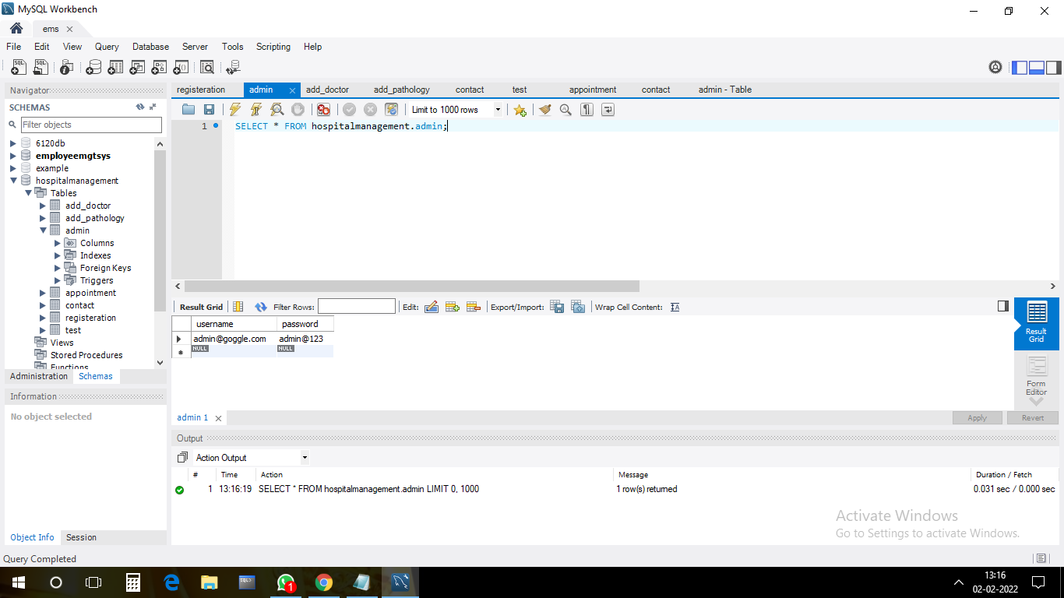

**2.2 Admin add Doctor Pages:**

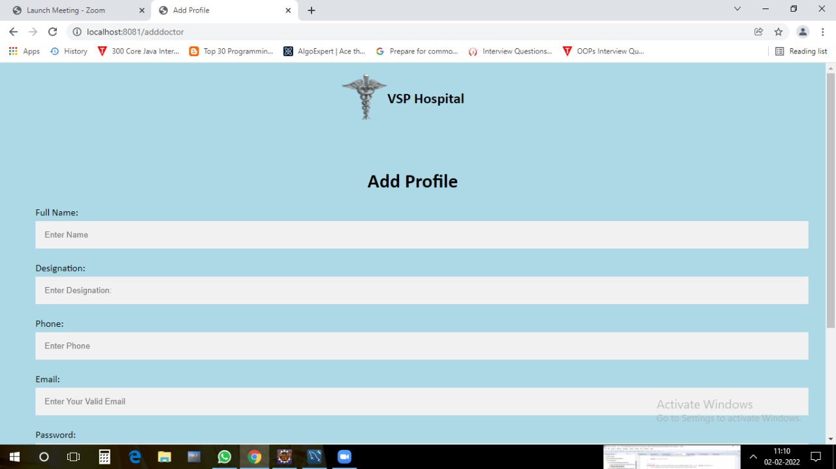

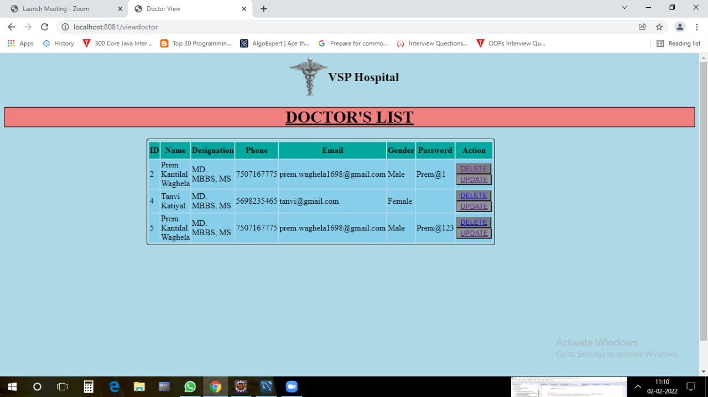

**2.3 Admin add Pathalogy Pages**

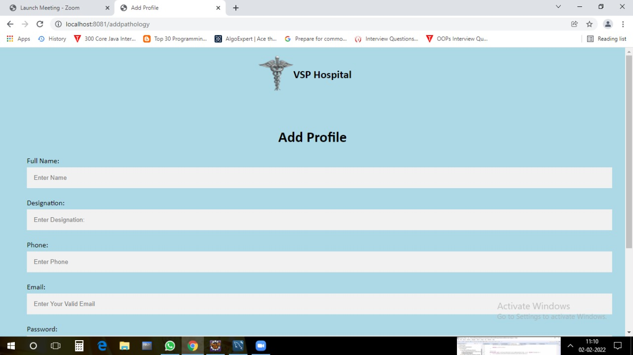

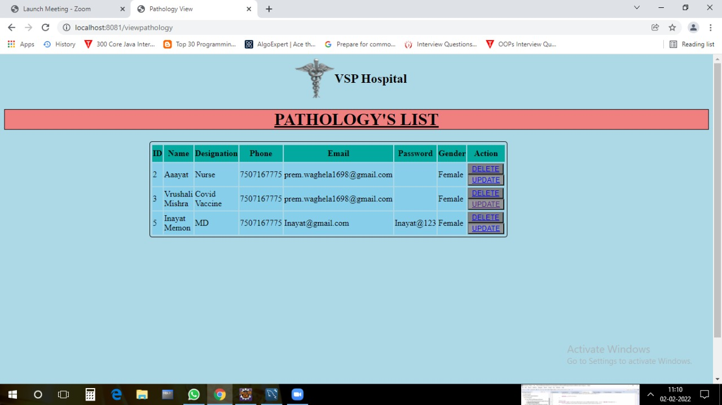

**3.Doctor Pages**

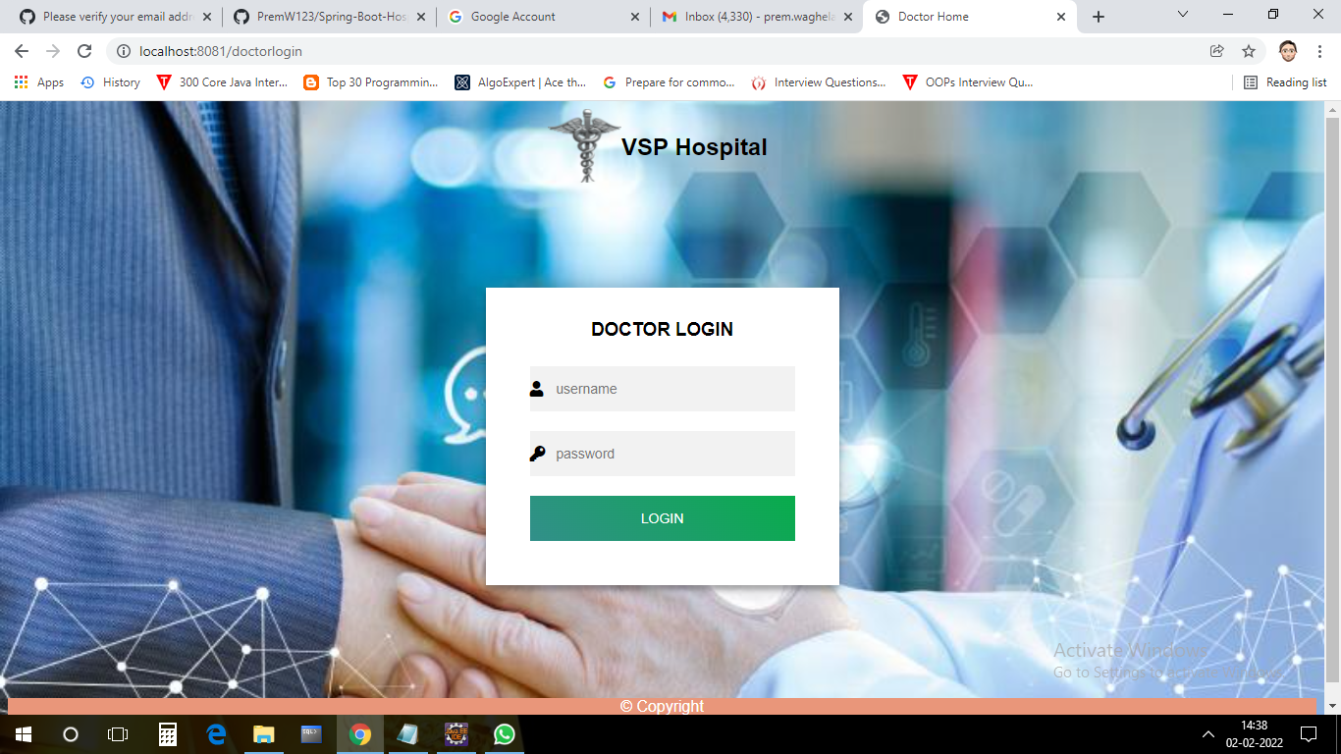

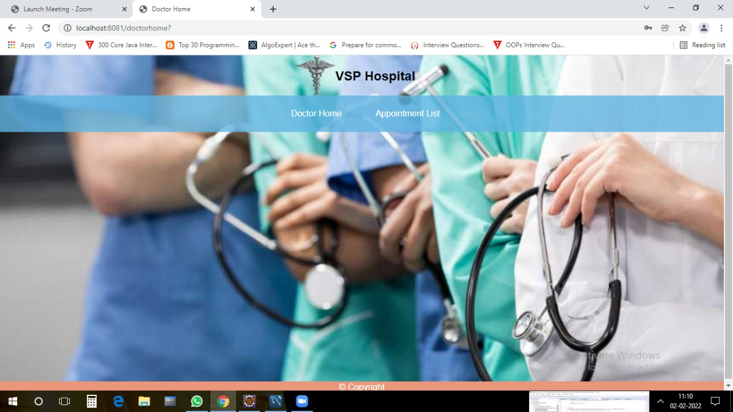

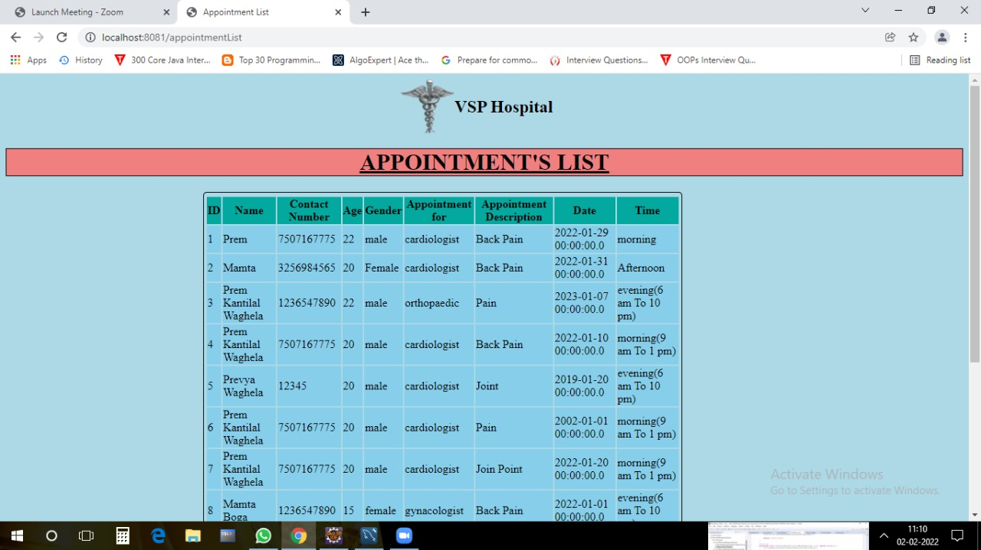

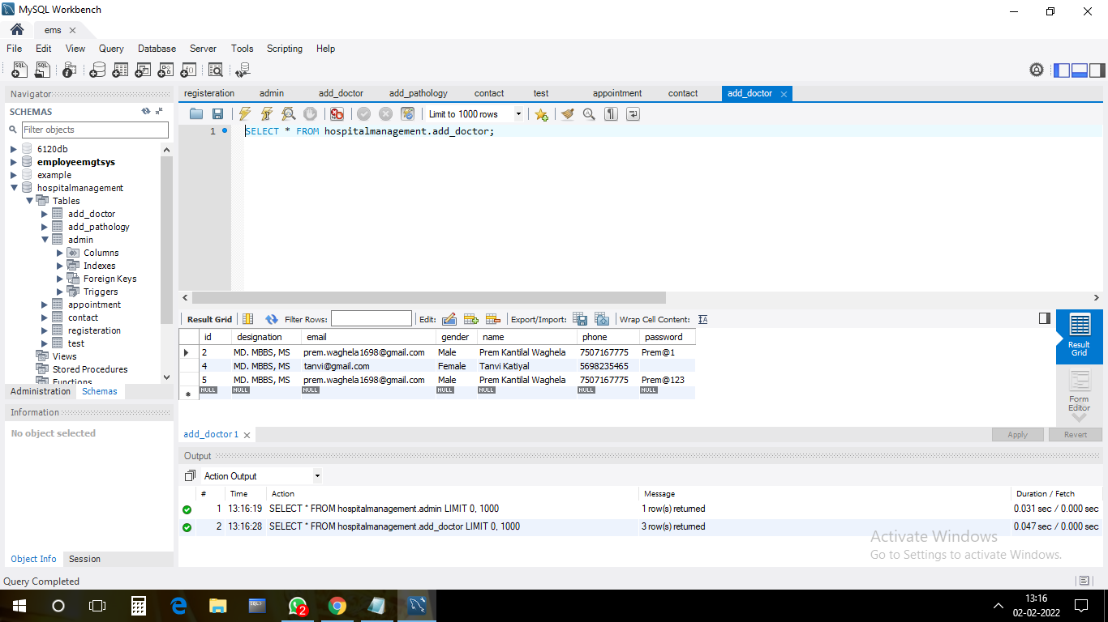

**4. Pathalogy Pages:**

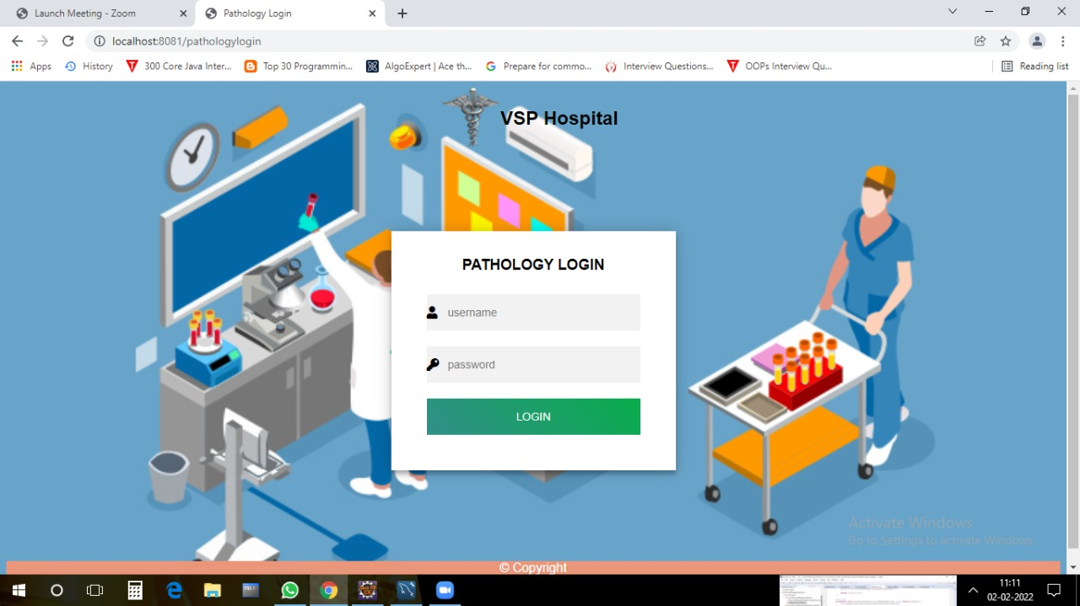

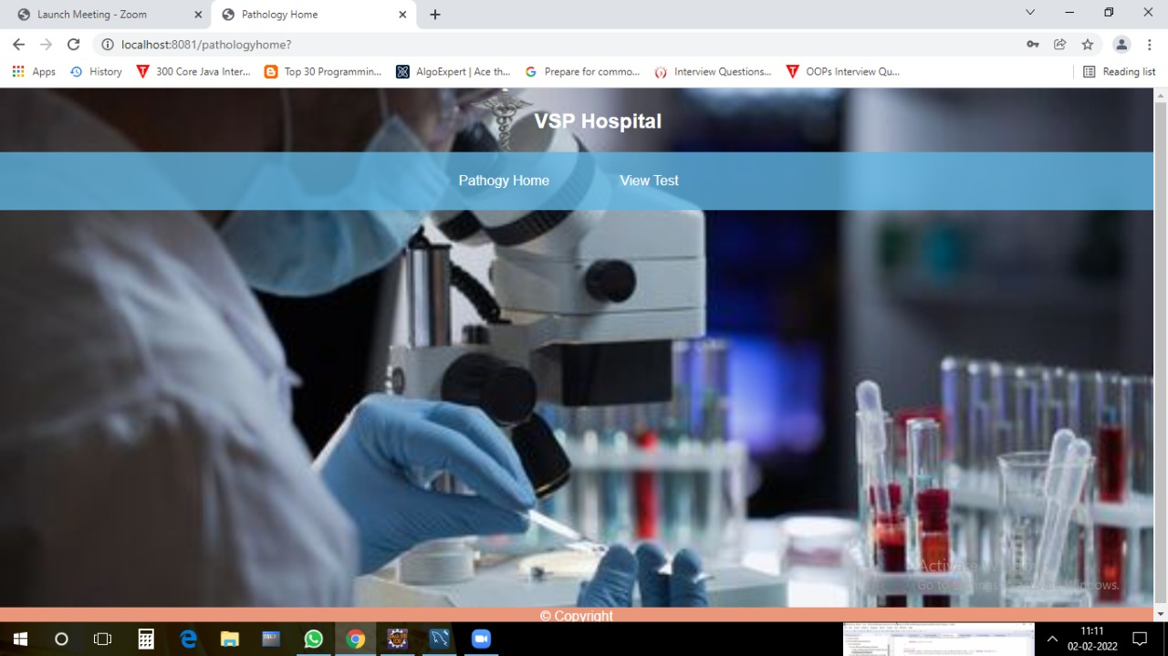

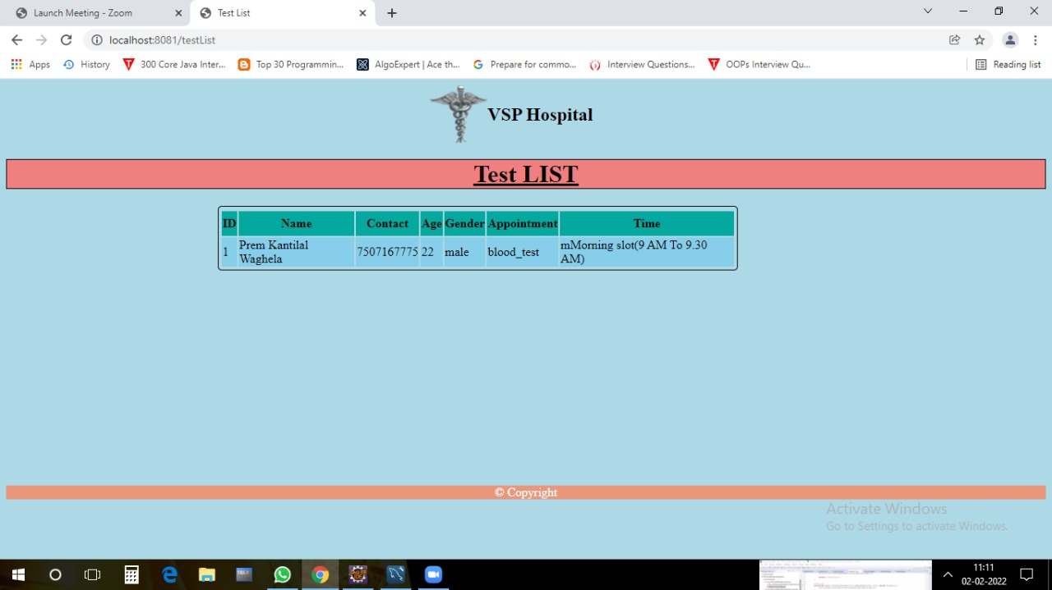

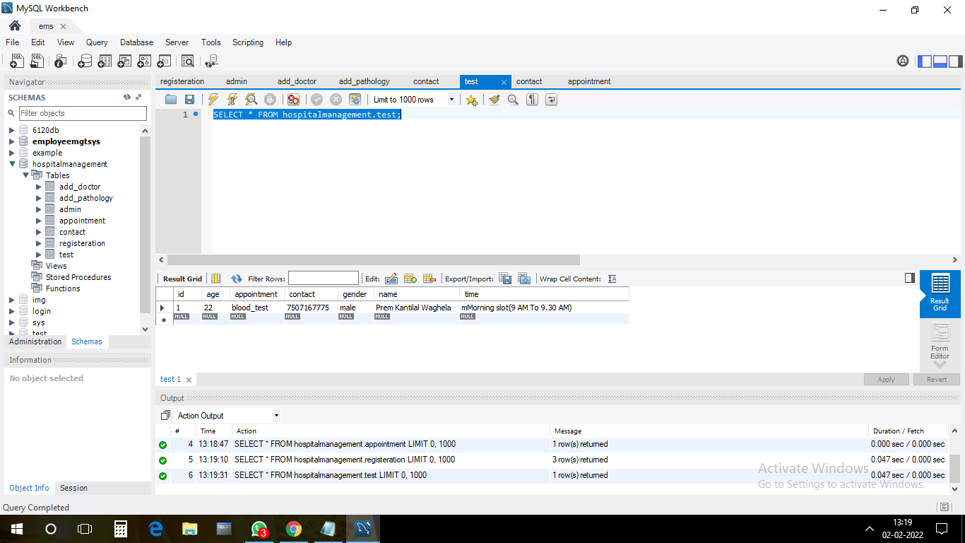

1. **Patient Pages:**

**1.Patient Registration:**

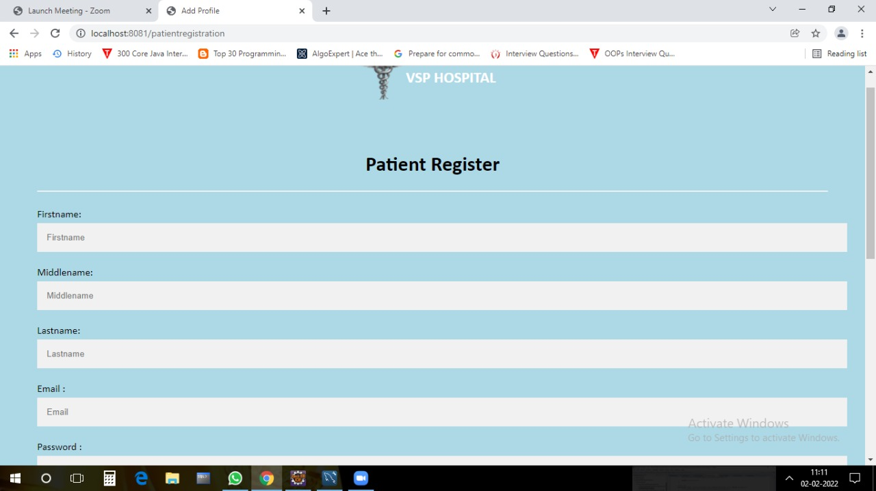

**2.Patient Login:**

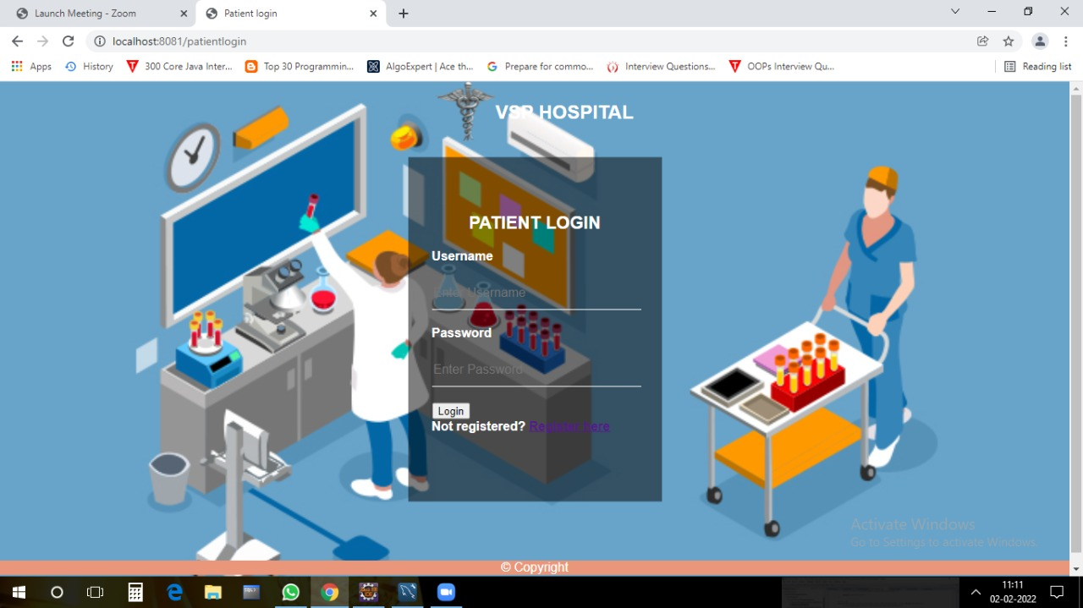

**3.Patient Home:**

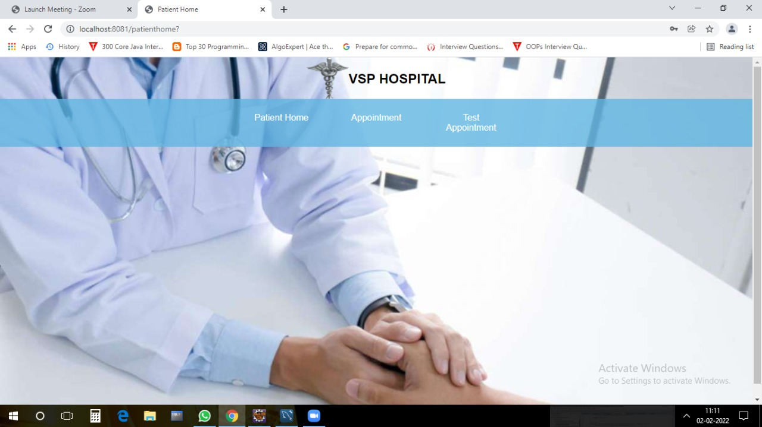

**3.Patient Appointment:**

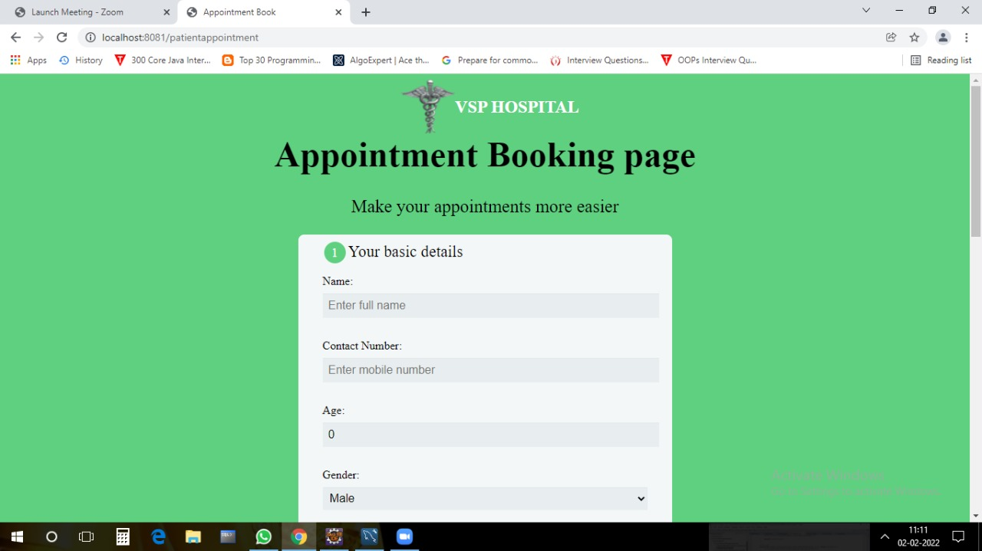

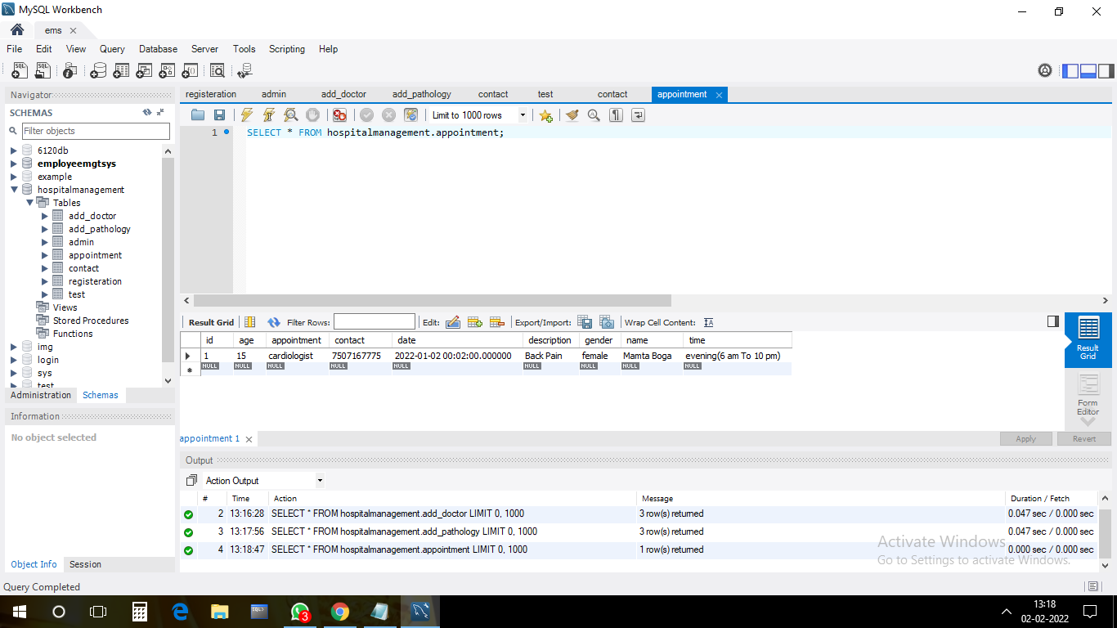

**4.Patient Test**:

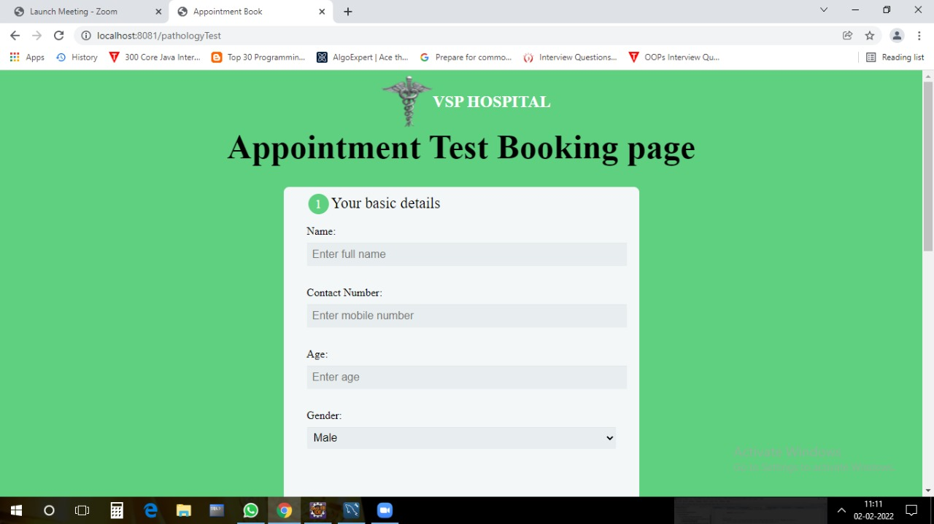



**5.About Us:**

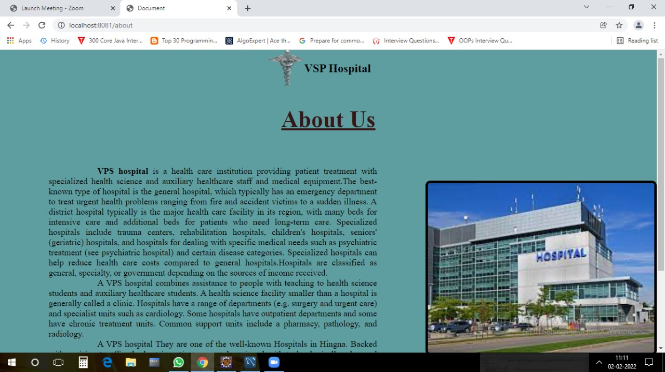

**6.Contact US**

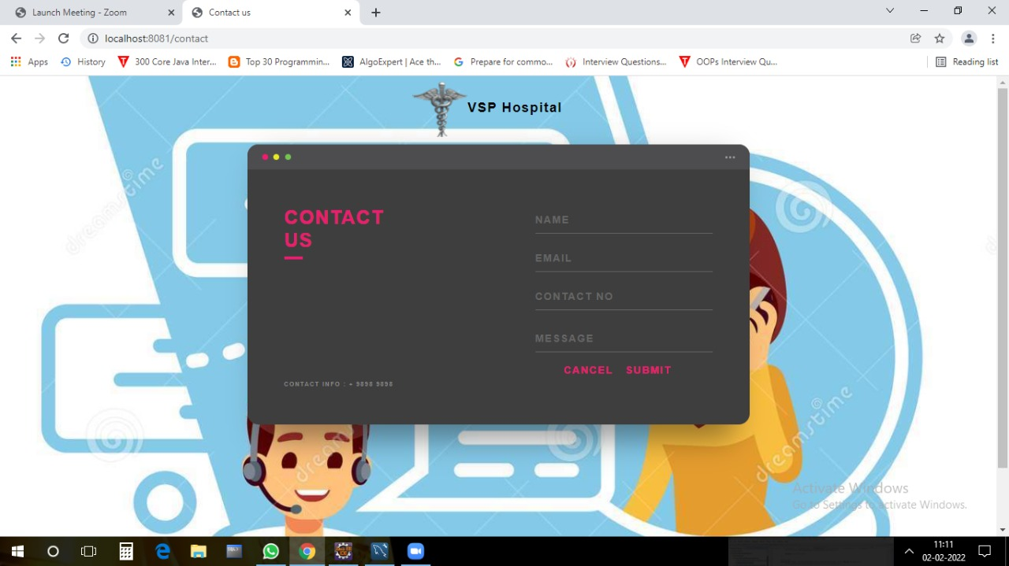

**Thank you**